Library of Copilot prompts

Email summary
Prompt to summarize initial email.
Help me summarize this e-mail draft. It should contain at least three key issues and provides five actionable next steps.

Supply chain issues review document
Creation of a word document outlining the problem and proposed action items.
Create a "Supply Chain Review" document. This report should be professionally formatted with consistent fonts and layout and include the following sections:
- Introduction
- Outline of the Business Problem
- Action Items
- Conclusion

Supply chain issues review invite
Invitation with agenda to meeting to handle the supply chain issues
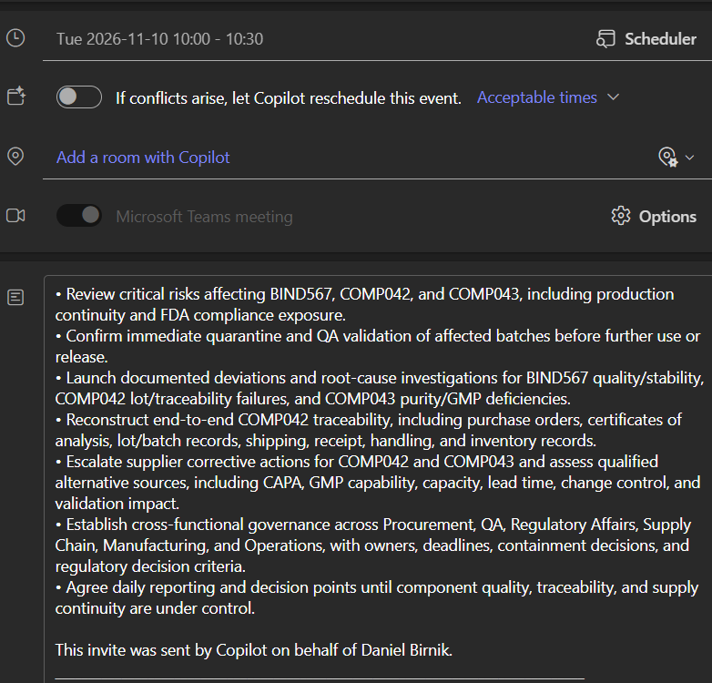

Summary of Teams transcript
Summary of notes from the meeting discussing the problems, solution and actions.
HI can You help me summarize the notes from the provided Teams transcript. The summary should include A clear overview of project goals. Key decisions and challenges. Actionable next steps.
Now create a professional project proposal summary including the following: Identification of problems. Suspected causes. Proposed approaches to resolution. Clear action items with assigned responsibilities.

Action Plan
Document providing clear immediate, short and medium term actions with assigned owners and deadlines.

Can you help me improve the layout of this document making it look clear, consistent and professional
Adjust this document taking into account the information in the attached file Action Plan - Planner Tasks.docx
Make the layout more professional by making it more easy visibly to see who is responsible for each action and the due date
Adjust the table so that it fits on the page

Supply chain report
Supply chain risk assessment analysis.
Analyze this workbook to uncover meaningful and interesting data insights. Include the 3 most important insights, findings, or takeaways, including a visualization to help illustrate or clarify a finding. Next, ask me questions to clarify what I'm interested in learning or suggest steps for deeper analysis. Insert the summary in a new sheet. The analysis should include the following: 1. Average delivery timeline by risk level 2. On-time delivery rate for delayed components (CARB123, BIND567, COAT890) 3. Supplier performance breakdown

Supply chain issues analysis report
Formal report on the analysis of he supply chain issues
in /word create a Supply Chain Issue Analysis Report containing: Executive Summary, Component Overview, Compliance Implications, Root Cause Analysis, and Mitigation Strategies.
This is regarding a pharmaceutical company so choose option 2
I can't download the word report there is no clickable link
It still doesn't render correctly. Paste the report so I can copy it into Word.

Can you help me improve the document. It should contain the following sections: Introduction, Outline of Business Problem, Action Items, and Conclusion. Also improve the layout making it professional and consistent.
Add a summary table in the Action Items section listing each mitigation step with its proposed timing and owners, taken from the existing text.
Refresh the table of contents so page numbers reflect the latest changes.
Add a one page executive summary at the start
Sorry I used the wrong input for the outline. The correct sections for the document should be: Executive Summary, Component Overview, Compliance Implications, Root Cause Analysis, and Mitigation Strategies. Can you revise the document based on this
Make each of the main sections start at a new page

Supply Chain Issue Compliance Report
Powerpoint presentation with speaker notes that communicates the Supply chain issues, the analysis and the solutions and implementation plan.
Create a Supply Chain Issue Compliance Report based on the attached file. The presentation has the following required elements: 1. Title Slide 2. Summary of Key Issues 3. Data Insights from Excel Analysis 4. Proposed Solutions 5. Implementation Plan Make the presentation graphically and visually appealing. The tone should be professional and it is important that the main information such as conclusions and actions get across to the audience Supply Chain Issue Analysis Report.docx

1. Which organization template should be used? PowerPoint-Template-Standard
2. What kind of images should I use? Branded and AI generated
Great, now can you generate speaker notes for the slide set?

